caAERS Business Rules Management Module

Technical Specification

Version History
Version | Date Modified | Author
0.1 | 10/18/07 | Vinay Kumar
0.2 | 10/18/07 | Srinivasa Akkala
0.3 | 10/18/07 | Karthik Iyer
0.4 | 10/19/07 | Ram Chilukuri
0.5 | 10/22/07 | Karthik Iyer

Contacts and Support
Vinay Kumar  vinay.kumar@semanticbits.com | NA
Srinivasa Akkala  srini.akkala@semanticbits.com | NA

LISTSERV facilities pertinent to software teams
LISTSERV | URL | Name
Caaersappdev-technical | caaersappdev-technical@gforge.nci.nih.gov. | caAERS technical forum
Table of Contents
1 Scope and Purpose 4
2 Overview 4
2.1 Features 4
2.2 Assumptions 5
3 Design Approach 5
3.1 Terms and Concepts 5
3.1.1 Rule 5
3.1.2 Rule Set 5
3.2 High Level Architecture 6
3.3 Domain Objects 7
3.4 Persistence Layer 9
3.5 Service Layer 9
3.6 Presentation/UI Layer 9
4 Implementation 11
4.1 Domain Model 11
4.2 Sequence Diagram 12
4.3 Activity Diagram 13
4.3.1 SAE Reporting Rules 13
4.3.2 Mandatory Section Rules 14

List of Figures
Figure 1: Rules are composed of conditions and invoke actions when triggered. 7
Figure 2: A ruleset is a collection of related rules. 8
Figure 3: High level architecture of rules module 8
Figure 4: Rule set XML schema 9
Figure 5: Categorization of rules based on whether they are specific to a sponsor, institution, or study 10
Figure 6: List rulesets page. 12
Figure 7: Select rule level page. 12
Figure 8: Create/edit rules page. 13
Figure 9: Domain model for rules. 13
Figure 10: Sequence diagram showing rule creation and deployment. 14
Figure 11: Sequence diagram showing rule execution. 14
Figure 12: Flowchart for the SAE reporting rules workflow. 16
Figure 13: Flowchart for the Mandatory sections rules workflow. 17

Scope and Purpose
This document gives the details of the rules module from architectural and design perspective. The scope of this document is limited to the design and implementation of the rules module. The document will also discuss the testing approaches for this module.

Overview
Rules that govern SAE reporting are complex and could vary from sponsor to sponsor, study to study and healthcare site to healthcare site. When certain criteria are satisfied a specific type of report should be submitted to variety of entities like the funding sponsor, coordinating center etc. That is, the type of SAE report that needs to be submitted to a sponsor or to any other interested agency may depends on a number of criteria. These criteria may also differ from study to study. Some studies may have much more strict criteria and some others may define relaxed criteria to reduce the number of SAE reports. Attributes from domain objects such as Study, AdverseEvent, etc. form the basis for defining the criteria. A rule is a set of criteria with one or more actions, which get executed when all the criteria in that rule are satisfied.
There are numerous use cases in caAERS, which dictate some kind of notification to be sent to interested parties by the system. In other cases, the system might be required to invoke some action/actions when certain pre-defined conditions are met. These conditions are based on the state of the domain objects. When a domain object achieves a predefined state then system has to perform preconfigured action(s). Definition of these conditions may change from time to time and/or from adopter to adopter, which introduces a lot of agility in business logic. Implementing the business rules using the classical approach of coding them as part business logic layer will necessitate changing the code and re-deployment of the application when rules change, which is not desirable and will lead to a maintenance nightmare.
Given the above problem statement, the caAERS team chose to implement the rules engine by integrating an open source rules engine called Java Rules (http://jcp.org/en/jsr/detail?id=94). The adoption of this approach gives the desired flexibility to caAERS adopters in defining rules, condition and pluggable actions. This will ease the process of introducing new rules or retiring old rules without redeploying the entire application. Rules and actions will be accessible to users in addition to system administrators. As a part of this effort, a Business Rule Management System (BRMS) has been developed and deployed as a part of caAERS application.

Features
Following is the list of the features introduced with rules module
- A web-based user interface for provisioning rules. This provides functionality to create, update, enable , disable and delete rules.
- Run time environment for execution of rules
- Grouping the rules based on their types (SAE Reporting Rules vs. Mandatory Sections Rules)
- Categorization of rules (Sponsor level rules vs. Institution level rules)
- Rules for assessing the adverse event
- Rules for report scheduling and notification

Assumptions

Design Approach
We define some terms and concepts before discussing the design approach. These terms and concepts will be used throughout the document.

Terms and Concepts

Rule
A rule is a definition that is applied to data to produce outcomes. A rule in caAERS has a two part structure consisting of a set of conditions and a set of actions. Conditions are defined using the definition of domain objects.
Following is an example of a rule:
Rule R1
if condition C1 and C2 are true
Fire Action A1, A2 and A3
.

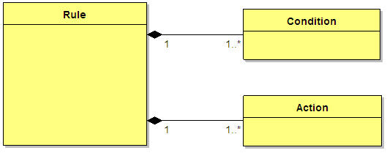
Figure 1: Rules are composed of conditions and invoke actions when triggered.

Rule Set
A rule set is a collection of related rules. For example one can define a rule set called “Adverse Event Assessment Rule Set” which has all the rules related to assessing the adverse event.
1
1…*
Rule
RuleSet
Figure 2: A ruleset is a collection of related rules.

High Level Architecture
The rules module consist of following components:
- Web interface to provision the rules
- Business service layer
- Rules run time environment
- Rules persistence

The diagram below shows the above mentioned components

Web Interface
Business service layer
Persistence layer
JBoss Rules
Other Business service layer
Rules run time
Database
Rules Auditing Module
Figure 3: High level architecture of rules module

Domain Objects
An XSD for rules is defined as part of rules module. Domain objects are generated from this XSD using JAXB (Java XML Binding). XML data binding refers to the process of representing the information in an XML document as an object. The following figure shows the high level view of XSD designed for rules module.

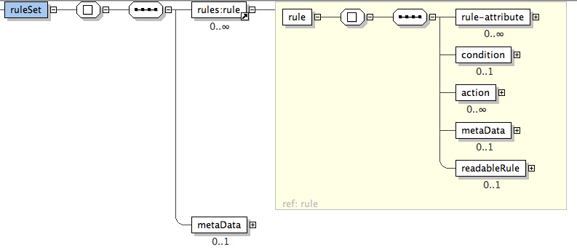
Figure 4: Rule set XML schema

The rules domain model is an abstraction layer which sits on top of the JBoss Rules object model. This not only eliminates the complexities involved in using the JBoss object model but also helps in providing a layer of indirection.
Figure 5: Categorization of rules based on whether they are specific to a sponsor, institution, or study
caAERS_rules_base
gov/nih/nci/cabig/caaers/rules
Sponsor
/sponsor
Institution
/institution
Sponsor 1
/sponsor1
Sponsor 2
/sponsor2

Study
/study

Ruleset 1
/ruleset1
Ruleset 2
/ruleset2
Ruleset 1
/ruleset1

Ruleset 2
/ruleset2
Study 1
/study1
Study 2
/study2
Sponsor 1
/sponsor1
Sponsor 2
/sponsor2

Institution 1
/instituition1
Institution 2
/instituition2

Study
/study

Ruleset 1
/ruleset1

Ruleset 2
/ruleset2

Ruleset 1
/ruleset1

Ruleset 2
/ruleset2

Study 1
/study1
Study 2
/study2
Institution 1
/instituition1

Institution 2
/instituition2

Institution 1
/instituition1

Institution 2
/instituition2

Sponsor 1
/sponsor1
Ruleset 1
/ruleset1
Ruleset 2
/ruleset2

Sponsor 2
/sponsor2

Ruleset 1
/ruleset1

Ruleset 2
/ruleset2

Ruleset 1
/ruleset1

Ruleset 2
/ruleset2

Ruleset 1
/ruleset1

Ruleset 2
/ruleset2

Ruleset 1
/ruleset1

Ruleset 1
/ruleset1

Ruleset 1
/ruleset1

Ruleset 2
/ruleset2

Ruleset 1
/ruleset1

Ruleset 2
/ruleset2

Ruleset 1
/ruleset1

Ruleset 2
/ruleset2

Sponsor level rules

Institution level rules

Sponsor level study specific rules

Institution level study specific rules

Persistence Layer
Rules in caAERS are stored in a content repository. Apache Jackrabbit – a fully conformant implementation of the Content Repository for Java Technology API (JCR) – is being used in caAERS.
Jackrabbit provides persistence manager components that facilitate the storage of content nodes and properties. Rule sets represent the content in caAERS.
The org.apache.jackrabbit.core.persistence.db.SimpleDbPersistenceManager class implements a generic Java Database Connectivity (JDBC) based persistence manager. Content is stored in a set of simple non-normalized tables that are created automatically.

Service Layer
The service layer consists of set of business services, each of which contains a number of coarse-grained methods that implement a group of related use cases.
Service layer is comprised of following services.
RulesEngineService – This service implements use cases such as
- Create Rule set
- Update Rule set
- Enable and Disable Rule set
- Delete Rule set
- Export/Import Rule set

AdverseEventEvaluationService – This service evaluates adverse events for seriousness, fires the configured rules and invokes the required actions.

Presentation/UI Layer
The presentation layer contains web components such as Java Server Pages (JSP) and Java servlets that can generate dynamic HTML content. The components in this layer are responsible for providing rule creation flow, deployment, import / export of rule sets. This layer is developed using Spring MVC framework and AJAX.
Below are the few screen shots of Rule Create/Edit Flow.

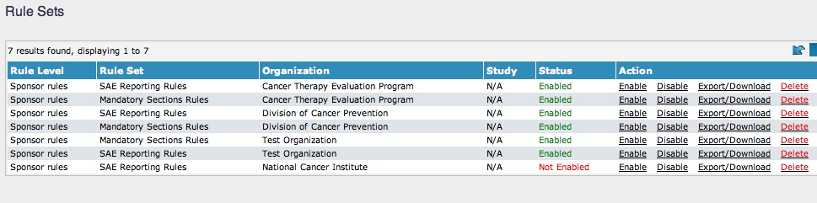
Figure 6: List rulesets page.

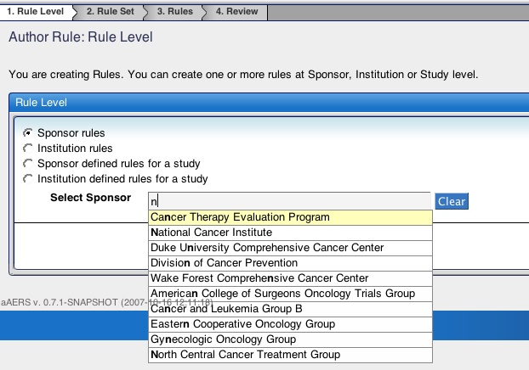
Figure 7: Select rule level page.

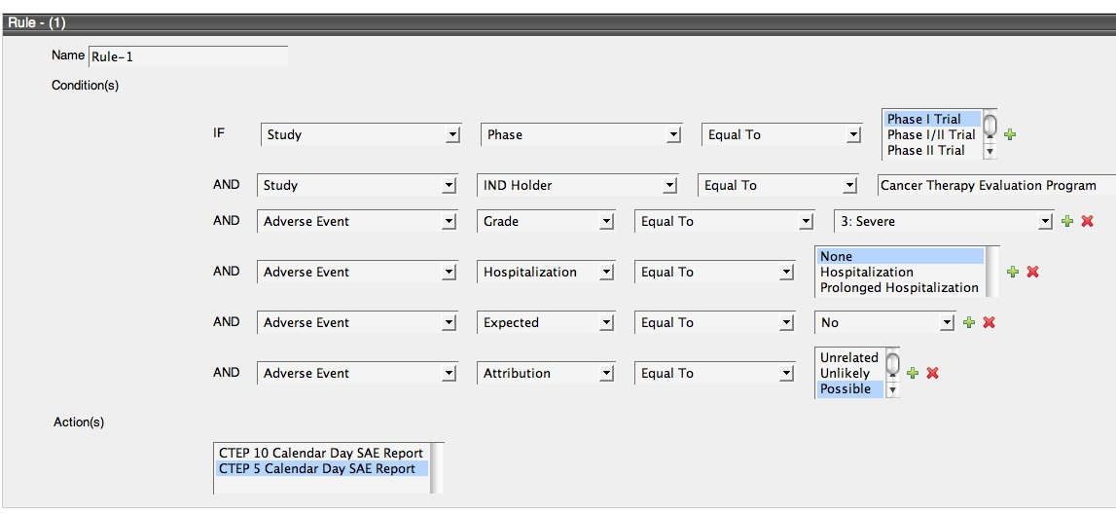
Figure 8: Create/edit rules page.

Implementation

Domain Model
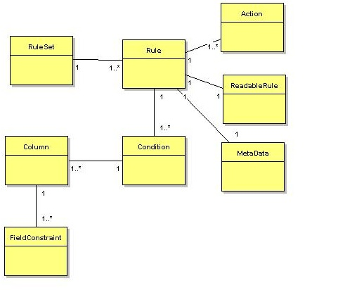
Figure 9: Domain model for rules.

Sequence Diagram

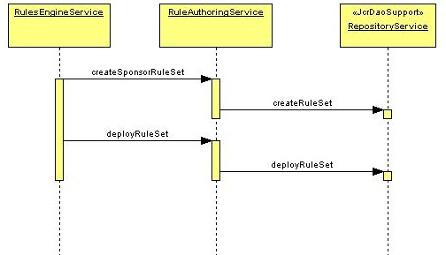
Figure 10: Sequence diagram showing rule creation and deployment.

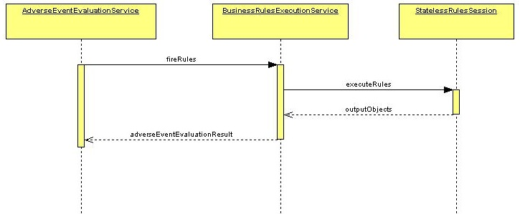
Figure 11: Sequence diagram showing rule execution.

Activity Diagram

caAERS supports two type of rule sets: SAE Reporting Rules and Mandatory Sections Rules. Following sections provide more details about these rule set types.

SAE Reporting Rules

This type of rules is being used to determine if an adverse event qualifies as a serious adverse event and thus requires expedited reporting. They indicate the appropriate reports that need to be submitted to various agencies such as the sponsor of the study, coordinating center for the study etc. SAE reporting rules are invoked in the Document AE’s and Enter expedited report workflows. Report definitions are specified as actions for rules of this type.
Following table enumerates the list of domain objects and their attributes that can be leveraged in defining the SAE reporting rules:

Domain Object | Attributes
Adverse Event | - Grade  - Hospitalization  - Expected  - Attribution  - CTC Category  - CTC Term  - MedDRA Term
Study | - Phase  - IND holder  - Therapy  - Treatment Assignment Code

Table 1: Domain objects and their attributes used in SAE reporting rules
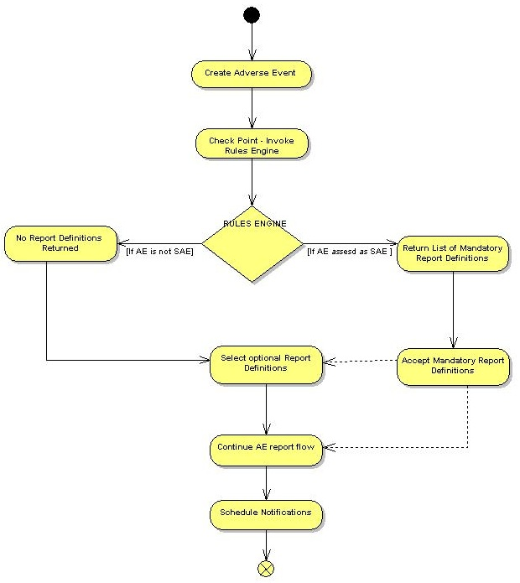
Figure 12: Flowchart for the SAE reporting rules workflow.

Mandatory Section Rules
This type rules aid in determining what sections are mandatory for a given report definition. These are invoked during the “Enter expedited report” workflow just after the reporter selects the report definitions. caAERS will permit the submission of these reports only after all the mandatory sections are completed.

Following table enumerates the list of domain objects and their attributes that can be leveraged in defining the mandatory section rules:
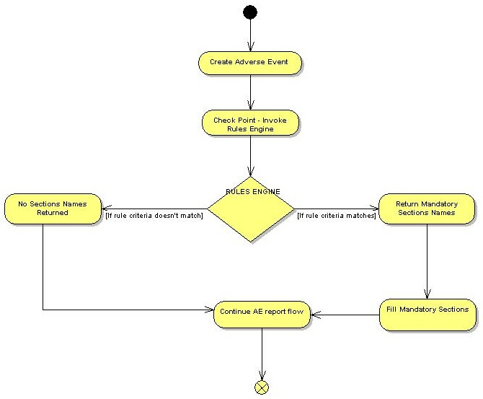

Figure 13: Flowchart for the Mandatory sections rules workflow.

Domain Object | Attributes
Adverse Event | - Grade  - Hospitalization  - Expected  - Attribution
Study | - Phase  - IND holder  - Therapy  - Treatment Assignment Code
Report Definition | - Name

Table 2: Domain objects and their attributes used in mandatory sections rules

